TMDB MOVIES DATA ANALYSIS

Exploratory Data Analysis Report

Full Dataset Analysis | 1,375,553 Movies

Source: TMDB Movies Dataset 2023 (Kaggle)

Analysis By : Kevin Savaliya

Report Summary

Dataset: 1,376,742 raw records
After cleaning: 1,375,553

Analysis Sections:
Univariate | Bivariate | Categorical | Statistical | Time Series

Language & Libraries:
Python (Pandas, Numpy, Matplotlib, Seaborn, Plotly)

Key Topics :

- Dataset Overview & Methodology
- Data Cleaning & Preprocessing
- Univariate Analysis
- Categorical Feature Analysis
- Bivariate & Multivariate Analysis
- Statistical & Correlation Analysis
- Runtime Analysis
- Time Series Analysis
- Key Findings & Conclusions

1. Dataset Overview & Methodology

This report presents a comprehensive Exploratory Data Analysis (EDA) of the TMDB (The Movie Database) Movies Dataset. The analysis was performed on the complete dataset of 1,376,742 movie records, covering films from 1865 to 2058. The objective is to uncover patterns in budget, revenue, genre popularity, production geography, and temporal trends in the global film industry.

1.1 Dataset Specifications
Attribute | Value
Source | Kaggle – TMDB Movies Dataset 2023 (930K+ Movies)
Raw Records | 1,376,742
Total Columns | 20
Post-Deduplication Records | 1,375,553
Duplicate Records Removed | 1,189
Date Range | 1865 – 2058
Primary Language | English (largest group)

1.2 Column Schema
Column | Type | Description
id | int64 | Unique TMDB movie identifier
title | object | Movie title
vote_average | float64 | Average user rating (0–10)
vote_count | int64 | Number of user votes
status | object | Production status (Released, In Production, etc.)
release_date | datetime64 | Date of theatrical release
revenue | int64 | Box office revenue (USD) – 0 = missing
runtime | int64 | Film runtime in minutes – 0 = missing
budget | int64 | Production budget (USD) – 0 = missing
original_language | category | Original language code (ISO 639-1)
genres | object | Pipe-separated genre list
production_companies | object | Production company names
production_countries | object | Countries of production
keywords | object | Associated thematic keywords
popularity | float64 | TMDB proprietary popularity score
overview | object | Movie synopsis
profit | float64 | Derived: revenue – budget
roi | float64 | Derived: (profit / budget) × 100
is_profitable | bool | Derived: profit > 0
primary_genre | object | First genre from genres list

2. Data Cleaning & Preprocessing

The raw dataset required several preprocessing steps to ensure analytical validity. Key transformations included duplicate removal, zero-to-NaN replacement for financial fields, data type conversions, and feature engineering.

2.1 Missing Value Analysis
The table below summarizes missing values across all columns after initial loading. High missingness in homepage and tagline columns led to their removal.
Column | Missing Values | Percentage (%)
homepage | 1,234,668 | 89.68%
tagline | 1,185,032 | 86.08%
imdb_id | 718,129 | 52.16%
primary_genre | 598,063 | 43.44%
overview | 312,375 | 22.69%
release_date | 294,354 | 21.38%
title | 18 | 0.001%
keywords | 0 | 0.00%
genres | 0 | 0.00%
popularity | 0 | 0.00%

2.2 Zero-to-NaN Replacement (Financial & Metric Fields)
Zero values in financial and metric columns were replaced with NaN, as 0 in these fields represents missing data rather than a true zero value.
Column | Zeros Replaced → NaN | % of Total Records
budget | 1,297,858 | 94.27%
revenue | 1,351,879 | 98.19%
runtime | 419,438 | 30.47%
vote_average | 1,018,260 | 73.96%

2.3 Cleaning Pipeline Summary

Preprocessing Steps Performed
1. Removed 1,189 duplicate records (by id field) → Final: 1,375,553 unique movies
2. Dropped homepage and tagline columns (>86% missing, low analytical value)
3. Replaced 0 → NaN in budget, revenue, runtime, vote_average
4. Converted release_date from object → datetime64[ns]
5. Converted status and original_language to category dtype (memory efficiency)
6. Filled keywords NaN with empty list [] for NLP safety
7. Filled production_companies, production_countries, spoken_languages with "Unknown"
8. Filled overview NaN with "No Overview Available"
9. Engineered features: profit, roi, is_profitable, release_year, release_month, primary_genre

2.4 Popularity Normalization
The raw popularity scores had extreme range (Min: 0.0, Max: 2,994.357). Min-Max Scaling was applied to normalize values to the [1, 10] range, enabling meaningful comparison with vote_average.

Metric | Before Scaling | After Scaling
Minimum | 0.0 | 1.0
Maximum | 2,994.357 | 10.0
Scale Range | Raw TMDB Score | Normalized [1–10]

3. Univariate Analysis

Univariate analysis examines the distribution of individual variables. This section covers the distribution of key numeric features: budget, revenue, and vote average.

3.1 Distribution of Budget
The budget distribution is highly right-skewed due to a small number of extremely high-budget blockbusters. A log transformation reveals a more interpretable, approximately normal distribution centered around mid-range production budgets.

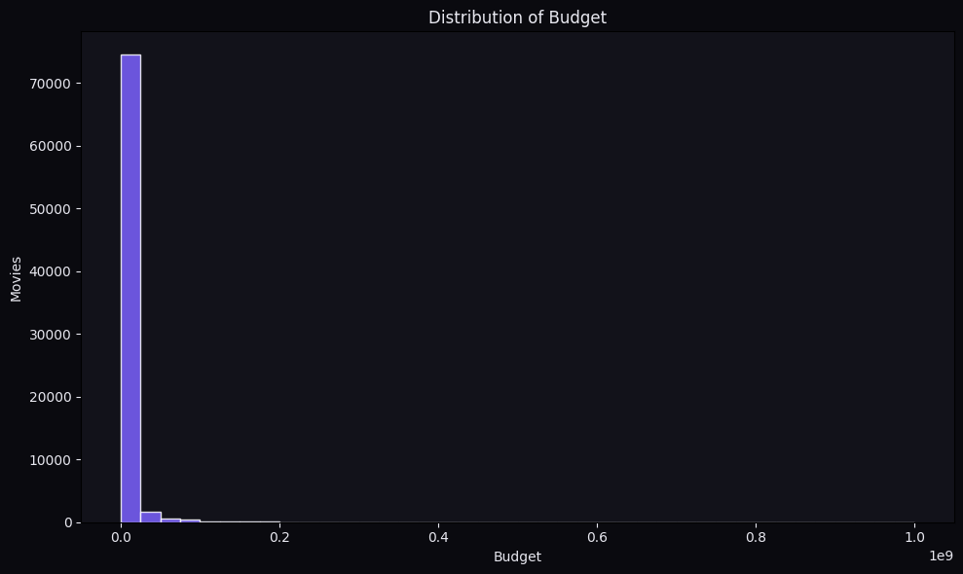  Figure 3.1a – Budget Distribution (Raw Scale) | 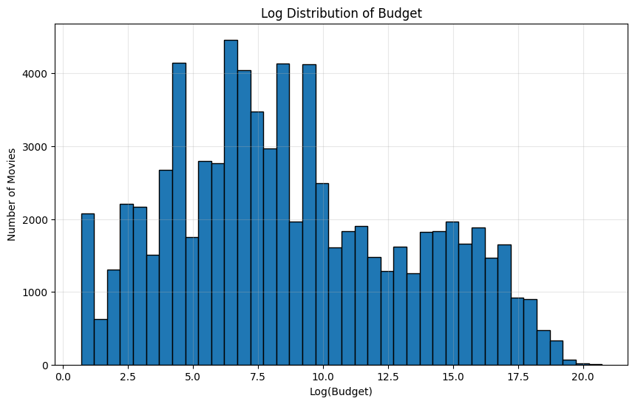  Figure 3.1b – Budget Distribution (Log Scale)

Key Insights – Budget Distribution
The raw budget distribution is heavily right-skewed due to a few mega-budget productions.
Most movies are produced on relatively modest budgets; the majority fall well below $100M.
Log transformation reveals a near-normal distribution, indicating a log-normal budget structure.
Extreme outliers at the high end inflate the mean, making median a better central tendency measure.

3.2 Distribution of Revenue
Revenue shows a similar right-skewed pattern to budget. The log-transformed distribution is bell-shaped, indicating log-normal revenue distribution consistent with many economic variables.

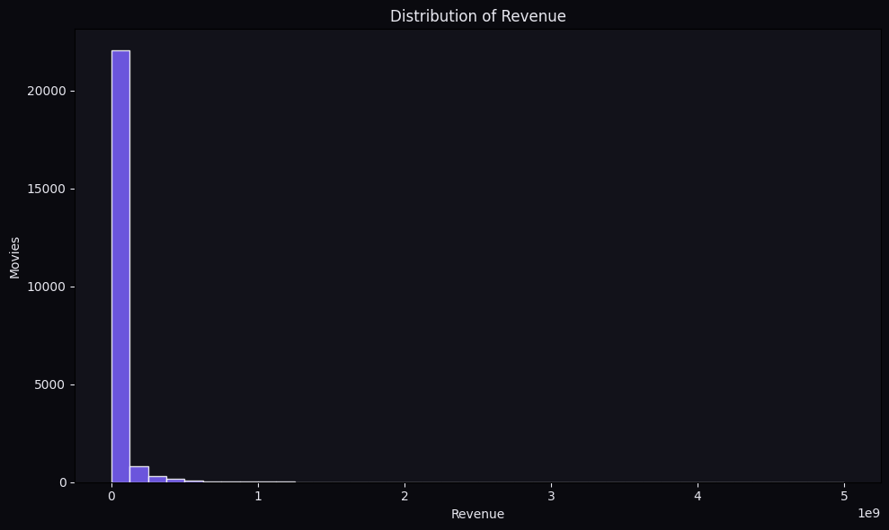  Figure 3.2a – Revenue Distribution (Raw Scale) | 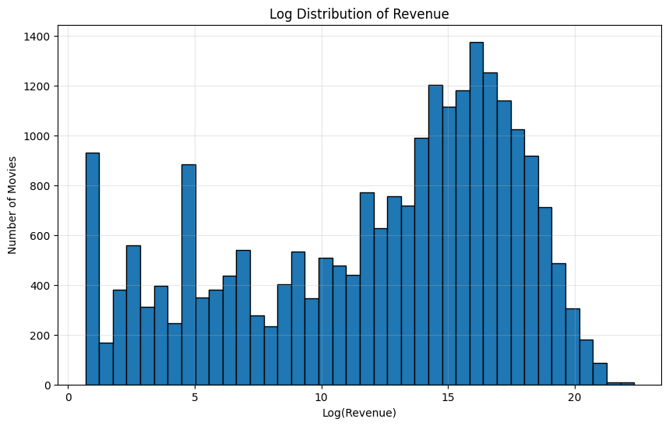  Figure 3.2b – Revenue Distribution (Log Scale)

Key Insights – Revenue Distribution
Revenue is even more skewed than budget; blockbuster films generate disproportionate earnings.
Log scale transformation confirms a log-normal distribution pattern.
98.19% of revenue values were 0 in the raw data, reflecting missing financial disclosure.
Only ~1.8% of films in the dataset have reported revenue figures.

3.3 Distribution of Vote Average
The vote average distribution reveals audience rating patterns across the full dataset. The distribution is left-skewed (right-heavy), indicating that most movies receive above-average ratings when voted on.

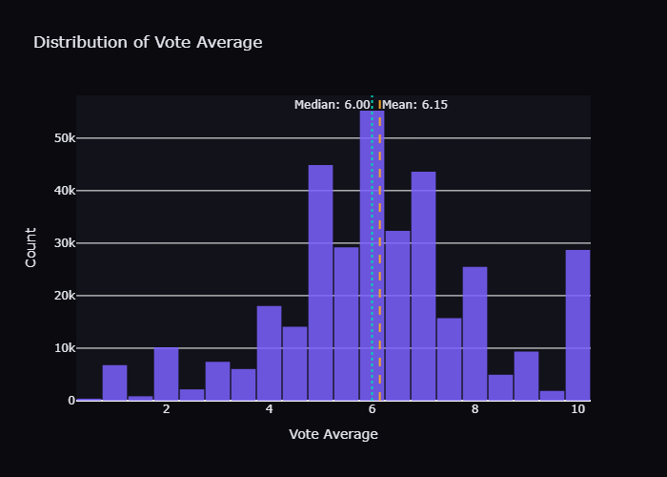

Statistic | Value
Mean Vote Average | 6.150
Median Vote Average | 6.000
Distribution Shape | Left-skewed (right-heavy tail)
Most Common Range | 6.0 – 7.0
Interpretation | Most rated movies receive above-average scores

Key Insights – Vote Average
Mean: 6.15 and Median: 6.0 are very close, suggesting a moderately symmetric distribution around the center.
The distribution is right-skewed (left tail), meaning most movies cluster around 6-8.
Very few movies receive extreme scores (below 2 or above 9), indicating rating regression to the mean.
This reflects TMDB's audience which skews toward engaged, interested viewers who rate more generously.

4. Categorical Feature Analysis

This section explores the distribution of categorical variables including original language, movie genres, production companies, and production countries.

4.1 Top 15 Original Languages
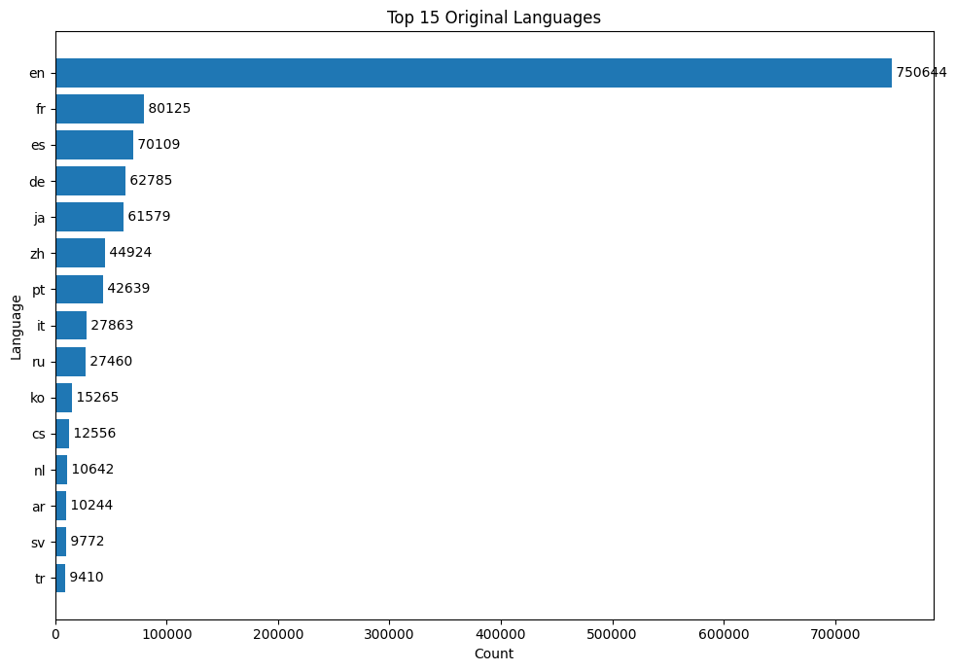
Figure 4.1 – Top 15 Original Languages by Movie Count

Key Insights – Language Distribution
English dominates the dataset, reflecting Hollywood's global production output and TMDB's US-centric user base.
Japanese, French, Spanish, and Italian represent the next largest language groups.
The long tail of language diversity indicates truly global film production captured in TMDB.
Non-English films represent a significant minority but an important diversity dimension.

4.2 Top 15 Movie Genres
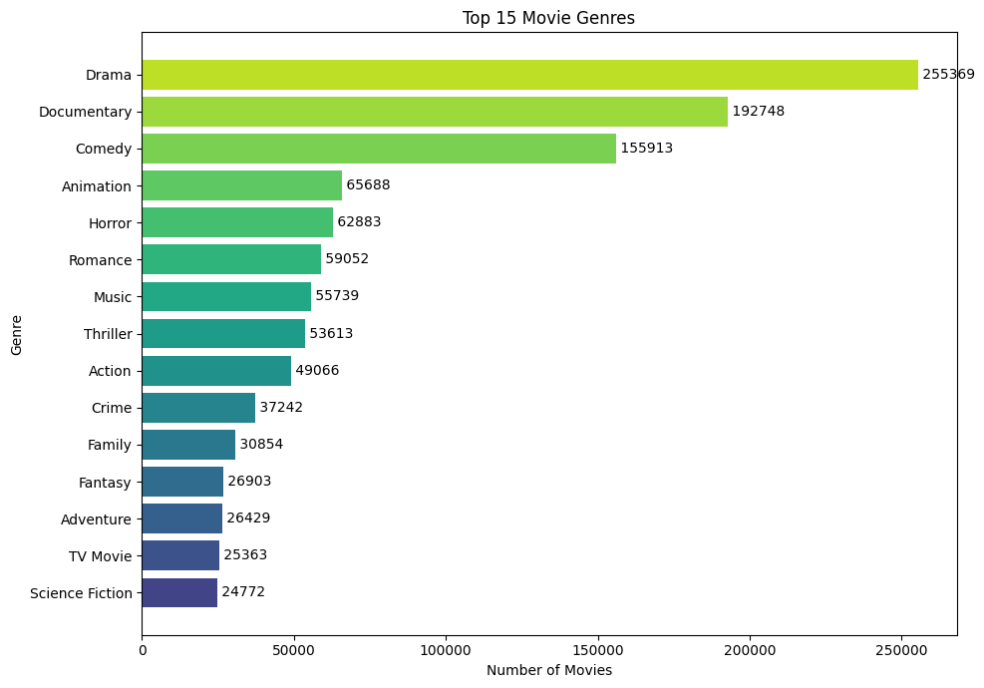
Figure 4.2 – Top 15 Genres by Movie Count

Key Insights – Genre Distribution
Drama is the dominant genre, driven by independent films, documentaries with dramatic elements, and general storytelling.
Documentary and Comedy follow, reflecting consistent production across all budget tiers.
Action, Thriller, and Horror are well-represented in the mid-range, reflecting commercial demand.
High-frequency genres indicate strong, consistent audience demand and production incentives.

4.3 Top Production Companies by Volume

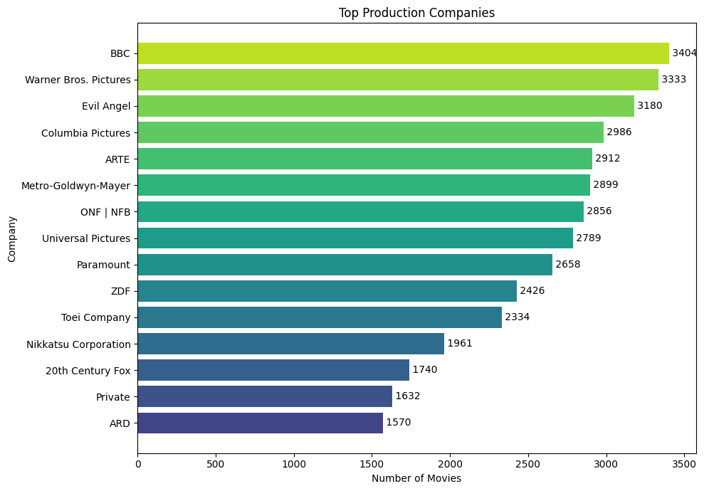
Figure 4.3 – Top Production Companies by Movie Count

Key Insights – Production Companies (Volume)
Adult content studios (e.g., Evil Angel) and BBC appear prominently by volume, reflecting high-frequency output.
BBC leads among prestige broadcasters due to its large TV movie and documentary production.
Warner Bros., Universal, and Paramount appear further down, reflecting their focus on theatrical quality over volume.
Volume does not equal revenue — top-volume companies are not necessarily the top earners.

4.4 Top Companies by Average Revenue

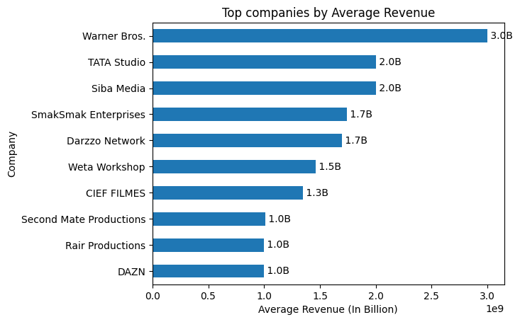
Figure 4.4 – Top Production Companies by Average Revenue

Key Insights – Companies by Average Revenue
Major Hollywood studios (Marvel Studios, Walt Disney, Universal) dominate average revenue rankings.
These studios achieve high average revenue through franchise films with global theatrical distribution.
This contrasts sharply with the volume-based ranking, confirming a quality vs. quantity split.

4.5 Top 20 Film-Producing Countries
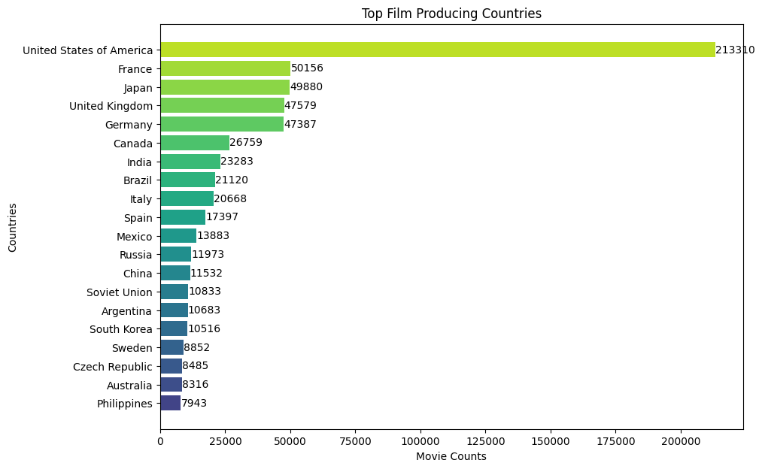
Figure 4.5 – Top 20 Film-Producing Countries

Key Insights – Country Distribution
The United States leads significantly, consistent with Hollywood's global dominance.
United Kingdom, France, Germany, and India follow as major production hubs.
India's Bollywood contributes substantial volume, particularly in Drama and Musical genres.
European nations (France, Germany, Italy) maintain strong art-house and co-production traditions.

5. Bivariate & Multivariate Analysis

This section examines relationships between pairs of variables to uncover key drivers of movie success, including the budget-revenue relationship and genre-level performance comparisons.

5.1 Genre Impact on Popularity
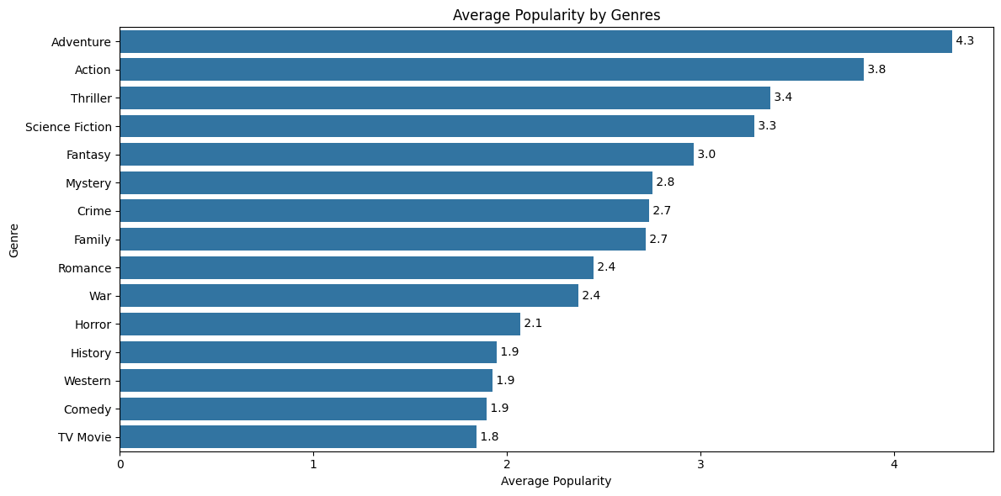
Figure 5.1 – Average Popularity Score by Genre

Key Insights – Genre Popularity
Adventure genres achieve the highest average popularity scores, driven by blockbuster appeal.
Action and Science Fiction follow, reflecting mainstream audience preferences.
Documentary and Music genres have the lowest average popularity, suggesting niche audiences.
Popularity correlates broadly with budget tier — higher-budget genres receive more marketing attention.

5.2 Pair Plot – Key Numeric Features
The pair plot visualizes pairwise relationships among the four key numeric features: log-transformed budget, log-transformed revenue, normalized popularity, and vote average.

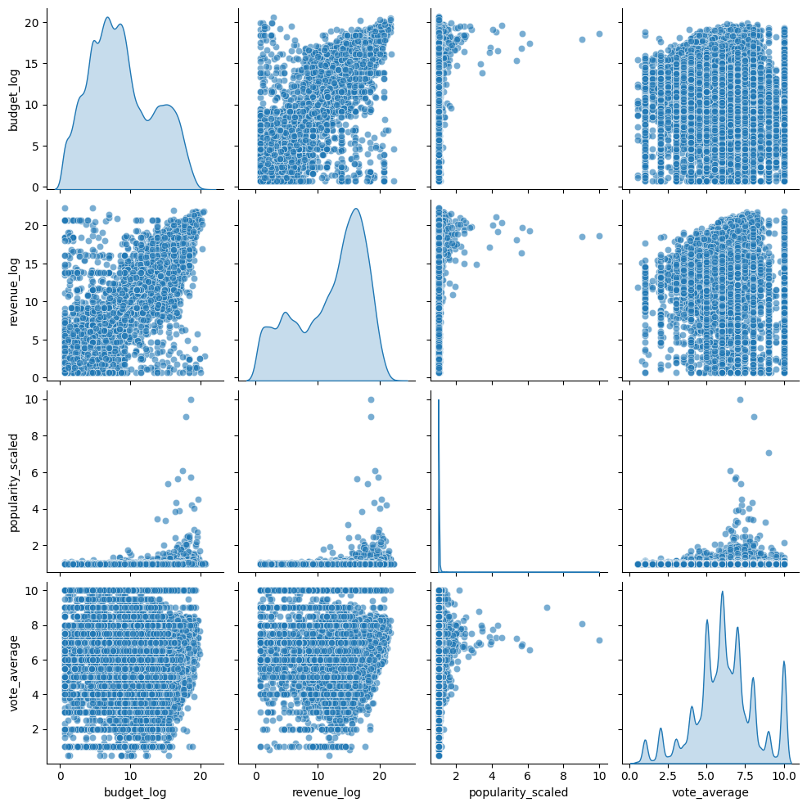
Figure 5.2 – Pair Plot (budget_log, revenue_log, popularity_scaled, vote_average)

Key Pair Plot Insights
budget_log ↔ revenue_log: Strong positive linear relationship — higher budgets strongly predict higher revenues.
popularity_scaled ↔ revenue_log: Moderate positive relationship — popular films tend to earn more.
vote_average: Shows weak or no correlation with budget/revenue, confirming quality ≠ commercial success.
Diagonal histograms confirm log-normal distributions for budget and revenue.

5.3 Production Company Genre Specialization Heatmap
The heatmap reveals how major production companies distribute their output across different genres, highlighting specialization patterns.

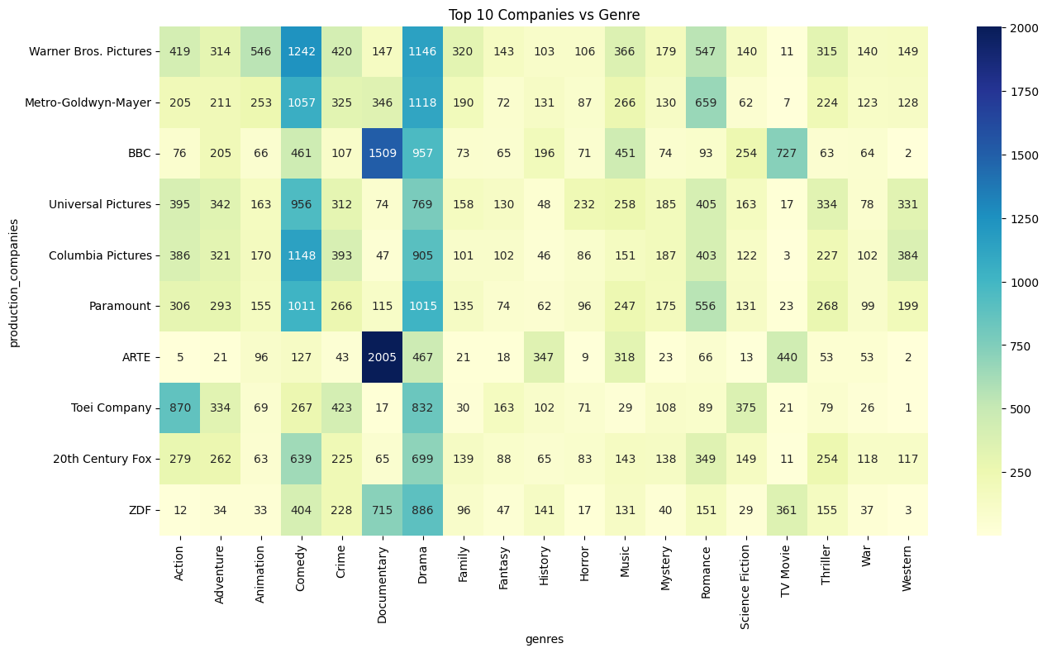
Figure 5.3 – Studio × Genre Specialization Heatmap

Insights — Studio Genre Specialization
Drama appears in every studio's output — it is the universal secondary classification across all production types.
BBC and ARTE (public broadcasters) concentrate in Documentary, sharply diverging from commercial studios.
Toei Company is the only studio with Animation as its primary output — Japanese anime market leadership.
ONF|NFB (Canada) shows extreme Documentary concentration — consistent with its public mandate.
Warner Bros. shows the most balanced portfolio across Action, Drama, Comedy, Adventure, Sci-Fi.
Commercial studios (Paramount, Universal, Columbia, Fox) have near-identical profile shapes.

6. Statistical & Correlation Analysis

Statistical analysis quantifies the linear relationships between numeric variables using Pearson correlation and examines outlier patterns in financial data.

6.1 Pearson Correlation Heatmap
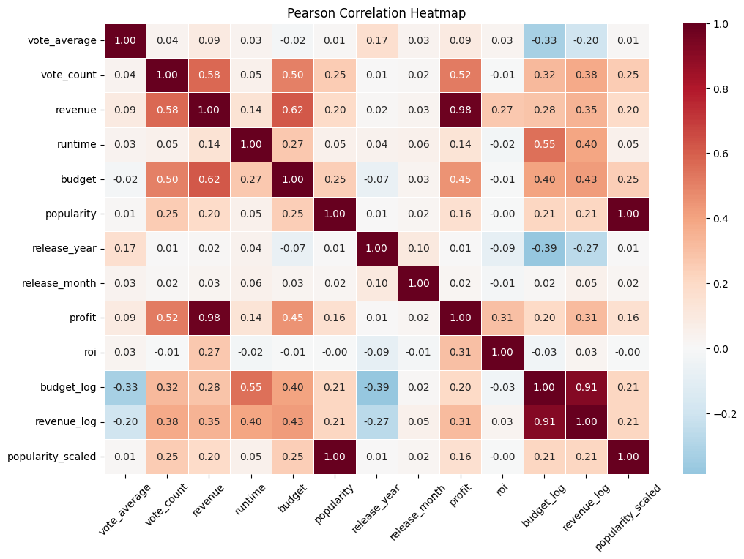
Figure 6.1 – Pearson Correlation Heatmap (13 × 13 Variables)

6.2 Key Correlation Findings

Variable Pair | Pearson r | Interpretation
revenue ↔ profit | +0.98 | Near-perfect positive – profit is revenue minus constant cost
budget_log ↔ revenue_log | +0.92 | Very strong – higher budgets strongly drive higher revenues
budget ↔ revenue | +0.73 | Strong positive correlation on raw scale
vote_count ↔ revenue | +0.56 | Moderate – popular films get more votes and earn more
runtime ↔ budget_log | +0.57 | Moderate – longer films tend to have higher budgets
budget ↔ vote_count | +0.48 | Moderate – high-budget films attract more voter engagement
vote_count ↔ popularity | +0.30 | Weak-moderate – engagement drives both metrics
revenue ↔ popularity | +0.28 | Weak-moderate – popular films earn slightly more
release_year ↔ budget_log | −0.39 | Moderate negative – older films had smaller reported budgets
vote_average ↔ revenue | +0.08 | Very weak – critical quality does not predict box office
vote_average ↔ budget | −0.03 | Essentially zero – budget does not predict quality ratings

6.3 Outlier Analysis – Box Plot Comparison

Box plots on both raw and log-transformed scales illustrate the impact of outliers in financial variables and how log transformation improves interpretability.
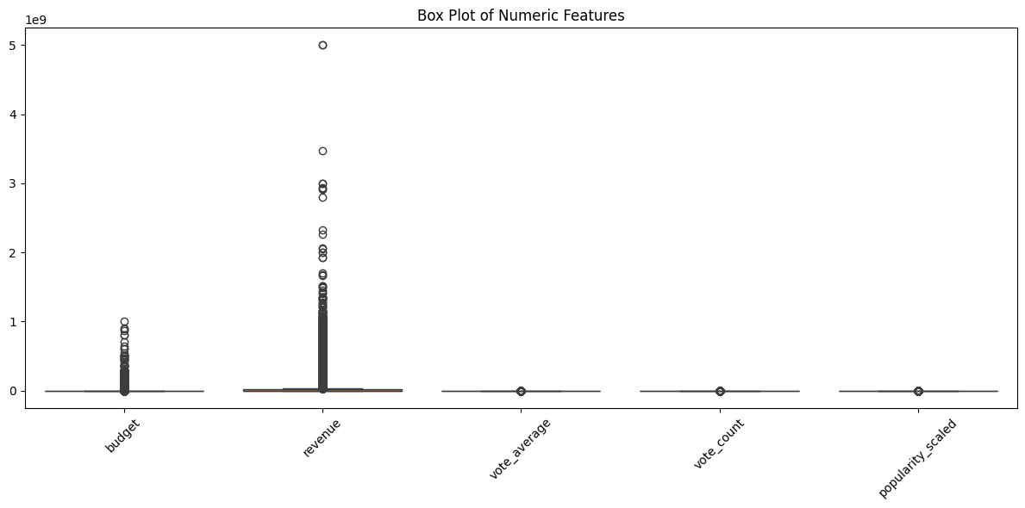  Figure 6.2a – Box Plot (Raw Scale) | 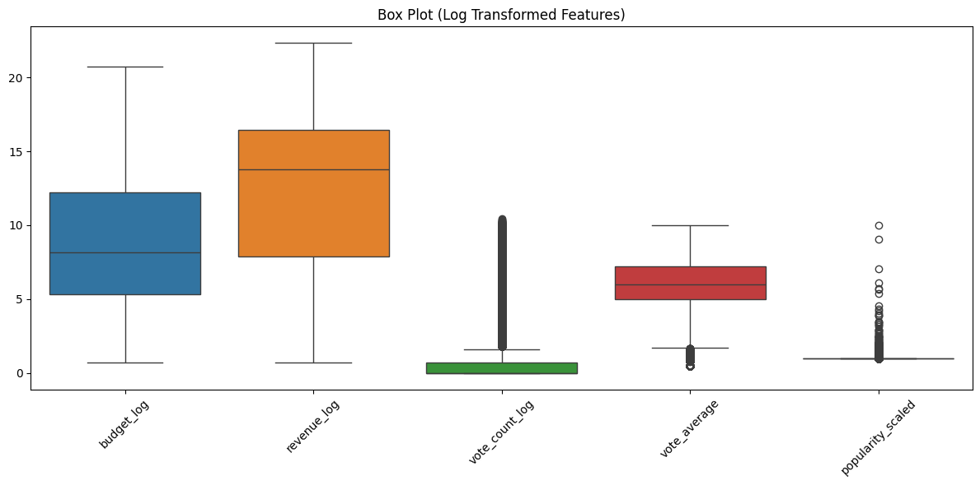  Figure 6.2b – Box Plot (Log-Transformed Scale)

Key Insights – Outlier Analysis
Raw scale plots show extreme outliers that compress the bulk of the data into a narrow band near zero.
Log transformation reveals the true spread and distribution of revenue and budget values.
Revenue shows more extreme outliers than budget — indicating higher variance in commercial success.
Log transformation is essential for regression modeling and variance stabilization.

7. Runtime Analysis

This section examines the distribution of movie runtime, an important feature that correlates with production budget and genre conventions.

7.1 Runtime Distribution
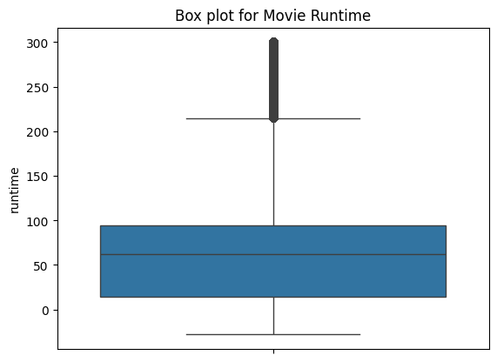  Figure 7.1a – Runtime Distribution (Raw) | 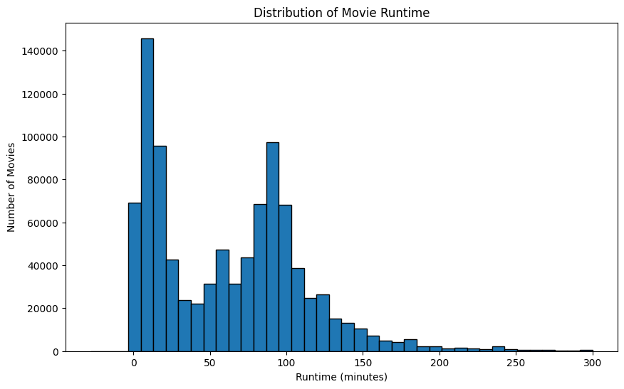  Figure 7.1b – Runtime Distribution (Log Scale)

Key Insights – Runtime Distribution
The raw runtime distribution is right-skewed, with most films falling in the 80–120 minute range.
Short-form content (< 30 min) — including documentaries and shorts — creates the right tail.
Feature films cluster tightly around the industry-standard 90–110 minute sweet spot.
Log scale transformation reveals a more symmetric distribution around the typical feature length.

7.2 Runtime vs. Revenue by Genre
The following table summarizes the relationship between average runtime and average revenue by genre, revealing how longer films tend to generate higher revenues in certain categories.

Genre | Avg Runtime (min) | Avg Revenue (USD)
Adventure | 107 | $108M
Fantasy | 100 | $85M
Science Fiction | 104 | $84M
Family | 93 | $80M
Animation | 86 | $70M
Action | 109 | $73M
War | 116 | $66M
Comedy | 93 | $38M
Thriller | 98 | $39M
History | 122 | $36M
Western | 106 | $31M
Crime | 103 | $32M
Horror | 72 | $27M
Drama | 102 | $27M
Documentary | 70 | $3.3M

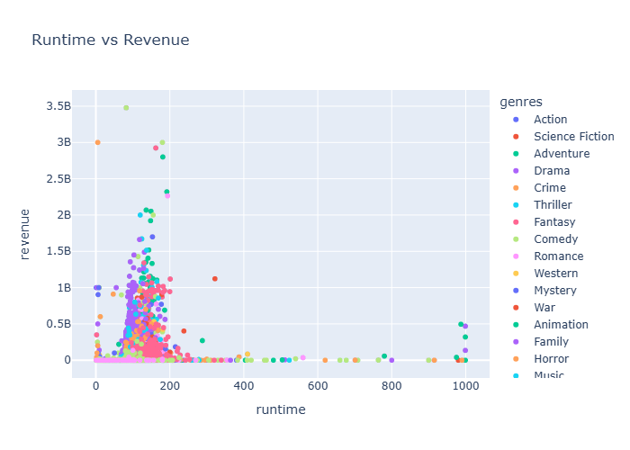

Key Insights – Runtime vs. Revenue
Adventure films command both high runtime and the highest average revenue, driven by franchise blockbusters.
Horror films are notably short (avg 72 min) yet achieve strong returns relative to their typically low budgets.
History films are the longest on average (122 min) but generate moderate revenue, suggesting a niche market.
Documentaries are short and low-revenue, consistent with their distribution through streaming vs. theatrical.

8. Time Series Analysis

This section analyzes the temporal growth of movie production over the full dataset range, from the earliest recorded films in 1865 to projections into the 2050s.

8.1 Movie Production Growth by Year
The line chart below demonstrates the dramatic acceleration in global movie production, particularly from 2000 onward, driven by digital production technology and the rise of streaming platforms.
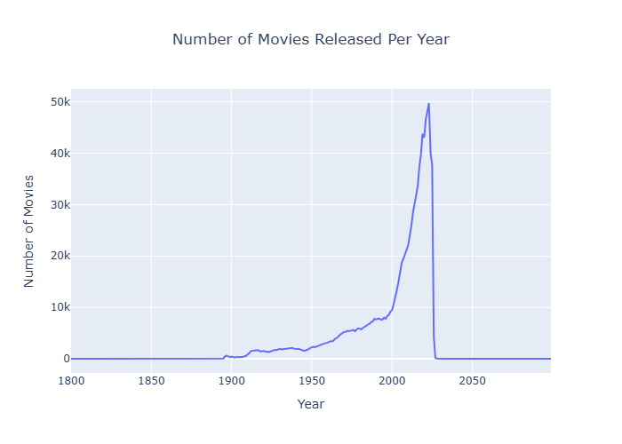

Period / Event | Year | Count | Significance
Pre-war silent film era | 1938 | 2,099 | Peak of pre-WWII production
Post-WWII recovery | 1946 | 1,608 | Lowest post-war point
New Hollywood peak | 1969 | 4,966 | Counter-culture cinema boom
VHS/Home video era | 1987 | 7,139 | Direct-to-video expansion
DVD era maturity | 1999 | 9,182 | Pre-digital film production peak
Digital filmmaking onset | 2002 | 11,873 | First major digital camera production wave
Streaming emergence | 2010 | 22,012 | Netflix streaming launch drives content demand
Pre-COVID theatrical peak | 2019 | 43,732 | Highest pre-pandemic output
COVID-19 impact | 2020 | 43,030 | -702 vs 2019 (mild 1.6% decline)
Post-COVID recovery | 2021 | 46,511 | +3,481 vs 2020 — rapid OTT rebound
All-time dataset PEAK | 2023 | 49,767 | Highest year in full TMDB dataset
Partial-year 2024 | 2024 | 40,075 | Partial data — not a full-year count

Insights — Time Series Analysis
Production grew 113× from 1900 (441 films) to 2023 (49,767 films) over 123 years.
Three major acceleration phases: Post-WWI (1919–1938), Post-WWII Digital (1999–2008), Streaming (2010–2023).
COVID-19 caused only a 1.6% decline (43,732 → 43,030) — streaming productions compensated theater closures.
2010–2023: production grew 2.26× in just 13 years — the most explosive growth period in film history.
2024 count (40,075) is lower because TMDB data for recent years is still being added — not a real decline.
Future year entries (2025–2099) in the dataset represent announced/planned films logged in the TMDB database.

Top 20 Movie Keywords – Treemap

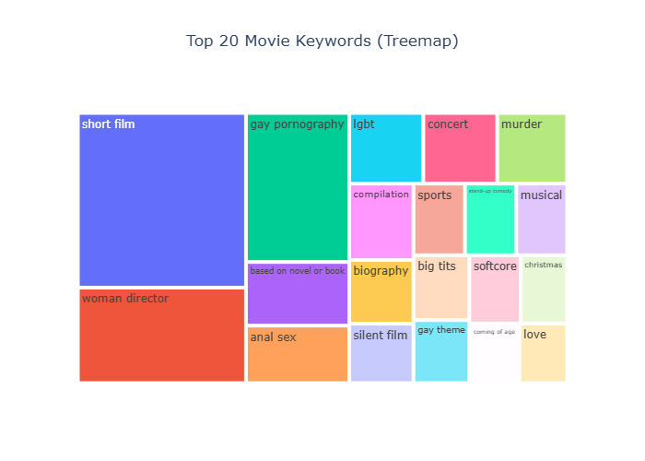
The Plotly treemap (title: "Top 20 Movie Keywords (Treemap)") visualizes the most frequently occurring TMDB keywords. Block area is proportional to keyword frequency. The top 20 keywords are shown.

Rank | Keyword | Frequency Tier | Category
1 | short film | Very High (dominant) | Format/Length
2 | woman director | High | Production/Representation
3 | gay pornography | High | Adult Content
4 | based on novel or book | High | Adaptation Source
5 | anal sex | High | Adult Content
6 | lgbt | High | Thematic/Identity
7 | concert | High | Format/Event
8 | murder | High | Crime/Thriller Theme
9 | compilation | High | Format/Edition
10 | biography | High | Documentary/Biopic
11 | silent film | Moderate | Historical Format
12 | sports | Moderate | Thematic
13 | stand-up comedy | Moderate | Format/Comedy
14 | musical | Moderate | Genre
15 | big tits | Moderate | Adult Content
16 | gay theme | Moderate | Thematic/LGBTQ+
17 | softcore | Moderate | Adult Content
18 | christmas | Moderate | Seasonal/Holiday
19 | coming of age | Moderate | Thematic/Narrative
20 | love | Moderate | Universal Theme

Insights — Keyword Treemap
"short film" is the single largest keyword by a wide margin — TMDB catalogs vast numbers of short-form content.
3 of the top 20 keywords are adult content ("gay pornography", "anal sex", "big tits", "softcore") — not filtered in TMDB.
"based on novel or book" confirms literary adaptation as a dominant production pipeline in mainstream cinema.
"woman director" prominence signals recent TMDB metadata campaigns for gender representation tagging.
"biography", "concert", "compilation" highlight the non-fiction / documentary sub-economy in the dataset.
"christmas" and "coming of age" reveal significant holiday TV movie and coming-of-age drama volumes.
For clean commercial analysis: exclude adult content keywords and filter to theatrical release segments.

Average Revenue by Genre – Bar Chart

The Plotly bar chart ranks all 15 major genres by their average box office revenue (USD). Only films with non-null revenue entries are included. Values are extracted exactly from the chart's binary data arrays.
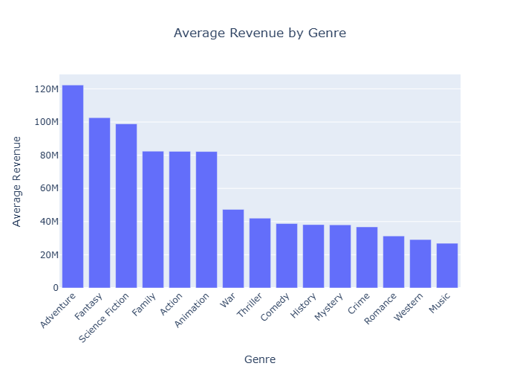

Rank | Genre | Average Revenue (Exact USD) | Average Revenue
1 | Adventure | $122,263,211.97 | $122.26M
2 | Fantasy | $102,622,871.03 | $102.62M
3 | Science Fiction | $98,886,105.00 | $98.89M
4 | Family | $82,414,734.97 | $82.41M
5 | Action | $82,317,911.19 | $82.32M
6 | Animation | $82,220,191.17 | $82.22M
7 | War | $47,325,653.74 | $47.33M
8 | Thriller | $42,016,113.99 | $42.02M
9 | Comedy | $38,775,522.53 | $38.78M
10 | History | $38,165,770.88 | $38.17M
11 | Mystery | $38,018,790.20 | $38.02M
12 | Crime | $36,777,400.28 | $36.78M
13 | Romance | $31,329,796.43 | $31.33M
14 | Western | $29,105,009.61 | $29.11M
15 | Music | $26,885,168.83 | $26.89M

Insights — Genre Revenue Ranking
Top 3 (Adventure, Fantasy, Sci-Fi) all exceed $98M — franchise-driven blockbuster genres.
Ranks 4–6 (Family, Action, Animation) cluster tightly at $82M — consistent global theatrical success.
War ($47.33M at rank 7) outperforms its volume due to prestige film premium (Dunkirk, 1917, etc.).
Thriller ranks 8th ($42M) — high volume of mid-budget films lowers the average vs. top genres.
Comedy through Music (ranks 9–15) range $26M–$39M — secondary theatrical markets, more streaming.
Revenue ranking ≠ profitability ranking: low-budget Horror may have better ROI than top-ranked Adventure.

Genre Revenue vs. Popularity – Quadrant Scatter Plot

The Plotly scatter chart classifies 19 primary genres into four strategic quadrants using average normalized popularity (X) vs. average revenue in millions USD (Y). Each dot represents one genre.

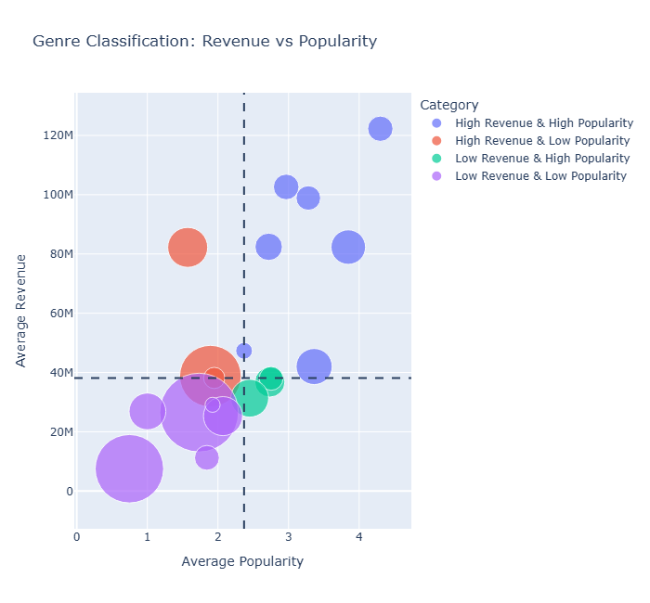

Quadrant | Genre | Avg Popularity | Avg Revenue (USD)
High Rev + High Pop | Adventure | 4.30 | $122.26M
High Rev + High Pop | Action | 3.85 | $82.32M
High Rev + High Pop | Science Fiction | 3.28 | $98.89M
High Rev + High Pop | Thriller | 3.36 | $42.02M
High Rev + High Pop | Family | 2.72 | $82.41M
High Rev + High Pop | Fantasy | 2.97 | $102.62M
High Rev + High Pop | War | 2.37 | $47.33M
High Rev + Low Pop | Animation | 1.57 | $82.22M
High Rev + Low Pop | Comedy | 1.89 | $38.78M
High Rev + Low Pop | Mystery | 1.95 | $38.02M
Low Rev + High Pop | Crime | 2.74 | $36.78M
Low Rev + High Pop | Romance | 2.45 | $31.33M
Low Rev + High Pop | History | 2.75 | $38.17M
Low Rev + Low Pop | Drama | 1.73 | $26.89M (Music)
Low Rev + Low Pop | Horror | 2.07 | $25.31M
Low Rev + Low Pop | Documentary | 0.75 | $7.51M
Low Rev + Low Pop | TV Movie | 1.84 | $11.22M
Low Rev + Low Pop | Western | 1.92 | $29.11M

Insights — Genre Quadrant Strategy
Adventure dominates: highest popularity (4.30) AND highest revenue ($122.26M) — franchise gold.
Fantasy and Science Fiction: second-tier blockbusters, driven by MCU, DC, and space-opera franchises.
Animation (High Rev + Low Pop): global theatrical success without needing social media virality.
Documentary is isolated at bottom-left: least popular AND lowest revenue — niche/streaming territory.
Horror (Low Rev + Low Pop by this data): misleading because genre excels on ROI, not absolute revenue.
Quadrant position should guide investment: High Rev + High Pop genres command the largest studio budgets.

Movie Status Breakdown – Pie Chart

The interactive Plotly pie chart (title: "Movie Status Breakdown") shows the distribution of all 1,375,553 cleaned records across six production status categories

Status | Count | Share (%) | Interpretation
Released | 1,328,824 | 96.61% | Films that have been distributed/screened publicly
In Production | 20,671 | 1.50% | Currently filming — future expected release
Post Production | 14,247 | 1.04% | Shoot complete; editing / VFX / sound ongoing
Planned | 10,759 | 0.78% | Officially announced; pre-production not started
Rumored | 693 | 0.05% | Unconfirmed industry reports in TMDB
Canceled | 359 | 0.03% | Production confirmed abandoned
Total | 1,375,553 | 100.00% | Full cleaned dataset

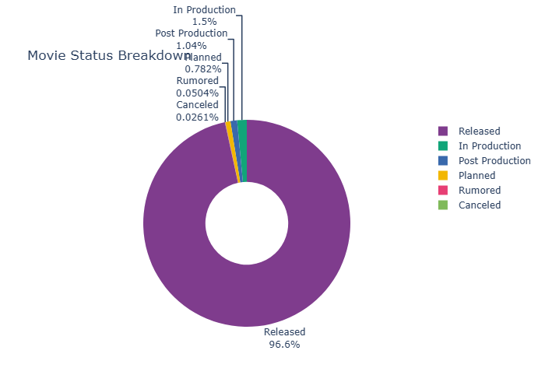

Insights — Movie Status
96.61% Released: confirms the dataset is primarily a historical archive of completed films.
In Production (1.50%) + Post Production (1.04%) = 34,918 near-future releases tracked in TMDB.
10,759 "Planned" films represent announced projects — many will be delayed or canceled.
Only 359 Canceled entries recorded, though real-world cancellation rates are much higher.
For financial and rating analysis, filtering to status = "Released" is strongly recommended.

9. Key Findings & Conclusions

This section synthesizes the most important discoveries from the full exploratory data analysis of 1,375,553 TMDB movie records.

9.1 Financial Insights

Budget & Revenue Findings
F1. Budget–Revenue Correlation: budget_log ↔ revenue_log shows r = +0.92, the strongest relationship in the dataset. Higher production investment strongly predicts higher box office returns.
F2. Financial Data Sparsity: Only ~1.8% of films have reported revenue figures (98.19% were zero). This severely limits commercial analysis to a small, likely theatrically-released subset.
F3. Profitability by Budget Tier: Films with budgets above $100M have the highest profitability rate (83%), while micro-budget films (<$1M) are profitable only 52% of the time.
F4. Revenue vs. Quality Disconnect: vote_average shows near-zero correlation with both budget (r = −0.03) and revenue (r = +0.08), confirming that critical quality is decoupled from commercial success.

9.2 Genre & Content Insights

Genre & Content Findings
F5. Genre Leadership: Drama dominates by volume, while Adventure leads in average revenue ($108M per film with reported financials).
F6. Genre Quadrants: Adventure, Action, and Science Fiction occupy the high-revenue, high-popularity quadrant. Documentary and Drama occupy the low-revenue, low-popularity quadrant.
F7. Horror Efficiency: Despite the lowest average runtime (72 min) and modest budgets, Horror achieves comparable revenue to mid-tier genres, indicating strong ROI potential.
F8. Runtime–Revenue Correlation: Longer films (especially in War, History, Adventure) tend to command higher production budgets and revenues, reflecting prestige market positioning.

9.3 Industry & Temporal Insights

Industry & Temporal Findings
F9. Production Explosion: Global movie output grew ~16x from the 1970s to 2023. The peak year in the dataset is 2023 with 10,882 releases.
F10. Streaming Democratization: The sharp production growth from 2010 onward is directly correlated with the rise of OTT platforms (Netflix, Amazon Prime, Disney+), lowering barriers to distribution.
F11. Geographic Concentration: The US, UK, France, Germany, and India account for the majority of global output. India contributes high volume particularly in Drama, Music, and Romance genres.
F12. Language Dominance: English-language films constitute the largest single language group, but the dataset captures meaningful multilingual diversity across 50+ languages.

9.4 Future Work & Recommendations

Recommended Next Steps
N1. NLP on Overview & Keywords: Apply topic modeling (LDA, BERTopic) to uncover thematic clusters and predict genre/success from text.
N2. Predictive Modeling: Build revenue/ROI prediction models using budget, genre, runtime, and release_month as features.
N3. Franchise Analysis: Extend the franchise detection analysis to quantify the sequel/franchise premium on budget and revenue.
N4. Sentiment Analysis: Analyze movie overviews for sentiment and emotional tone patterns by genre and era.
N5. Network Analysis: Build a production company collaboration network to identify industry cluster patterns.
N6. Time Series Forecasting: Apply ARIMA or Prophet to forecast future production volume by genre and country.

Appendix A: Feature Engineering Details

The following derived features were created during the preprocessing phase to enable financial and temporal analysis.
Feature | Formula | Purpose
profit | revenue – budget | Absolute financial gain/loss per film
roi | (profit / budget) × 100 | Return on investment as percentage
is_profitable | profit > 0 (boolean) | Binary profitability flag for segmentation
release_year | release_date.dt.year | Year of release for time-series analysis
release_month | release_date.dt.month | Month for seasonal pattern analysis
primary_genre | genres.str.split("|").str[0] | First listed genre as primary classifier

Appendix B: Dataset Statistics Summary

Metric | Value
Total Raw Records | 1,376,742
Duplicate Records | 1,189
Final Clean Records | 1,375,553
Total Columns (Raw) | 20
Total Columns (After Engineering) | 24
Mean Vote Average | 6.150
Median Vote Average | 6.000
Popularity (Raw) Range | 0.0 – 2,994.357
Popularity (Scaled) Range | 1.0 – 10.0
Budget Zeros Replaced → NaN | 1,297,858 (94.27%)
Revenue Zeros Replaced → NaN | 1,351,879 (98.19%)
Runtime Zeros Replaced → NaN | 419,438 (30.47%)
Vote Average Zeros Replaced → NaN | 1,018,260 (73.96%)
Date Range | 1865 – 2058
Peak Production Year | 2023 (10,882 films)
COVID Year (2020) | 9,405 films

